**What is SDLC ?**

SDLC is a software development life cycle.

**What is software testing ?**

Software testing is a process of executing a program or application with the intent of finding the software bugs.

**What is agile methodology ?**

It is a combination iterative and increment model

It divides the software into small incremental builds this build are provided in iteration , that means the bug projects are divided into small chunks.

**What is SRS** ?

SRS is a complete description of an application which is to be developed .

**What is oops** ?

Object oriented programming is way of writing the programme is organized way object .

**Write basics concept of oops ?**

* Class
* Object
* Inheritance
* Polymorphism

Overloading

Overriding

* Encapsulation

**What is object ?**

Object gives the permission to access functionality of the class .

**What is class ?**

Class is a collection of data member function .

**What is encapsulation ?**

The process wrapping the data in a single unite. To secure the data from outside world.

**What is inheritance ?**

Making a class from an existing class deriving the attribute of some other class.

**What is polymorphism ?**

One name multiple form

**Type**

* Over riding = Same name of function with some parameter but definition will be different .
* Over Loading = function over loading – same function name but different parameter.

**Draw use case on online book shopping ?**

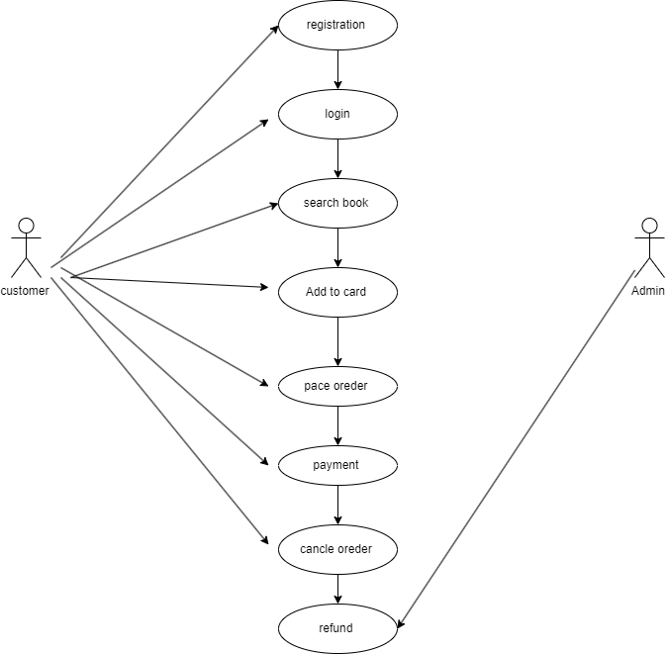

**Draw usecase on online bill payment system (paytm) ?**

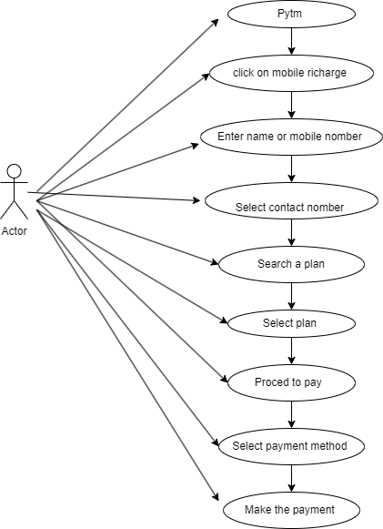

**Write SDLC phases with basic introduction ?**

|  |  |
| --- | --- |
| Requirements collection / Gathering | Establish customer needs |
| Analysis | Model and specify the requirements – ‘what’ |
| Design | Model and specify a solution – ‘why’ |
| Implementation | Construction the solution in software |
| Testing | Validate the solution against the requirements |
| Maintenance | Repair defects and adapt the solution to the new requirement |

**Explain phases of the waterfall model ?**

* Requirements collection
* Analysis
* Design
* Implementation
* Testing
* Maintenance

**Write phases of spiral model ?**

* Planning = determination of objectives, alternatives and constraints initial requirements
* Risk Analysis = Analysis of alternatives and identification / solution of risk
* Engineering =
* Alpha demo customer evolution = Assessment of the results of engineering

**Explain working methodology of agile model and also write pros and cons ?**

* It is a combination iterative & incremental model.
* It divided the software into small incremental builds, this build are provide in in iteration, that means the big projects are divided into small chunks.
* Each iteration last about one to three weeks.
* At the end of the iteration the working product is displayed to the customer or the important stoke holder & it is released in the market
* After the release we check for the feedback of deployed software
* In any enhancement is needed in the project then it’s done & it’s released.

**PROS**

* Frequent delivery
* Face to face communication with the customer
* Less time
* Adaptability

**CONS**

* Less decomentation
* Maintenance

**Draw use case on online shopping product using COD**

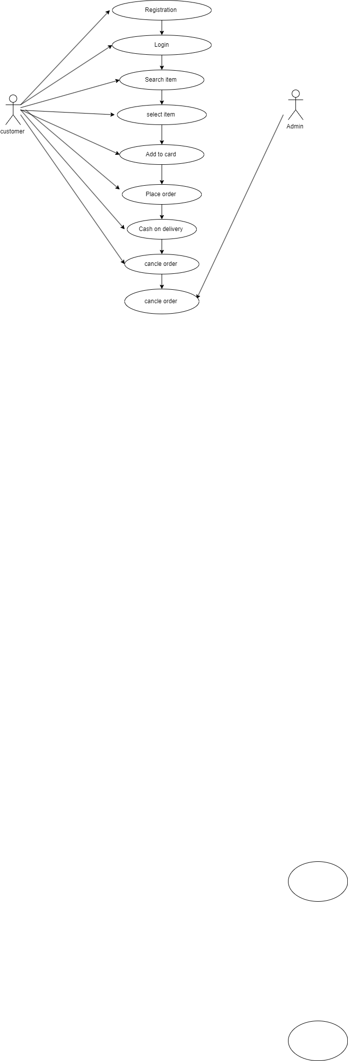

**Draw use case on online shopping product using payment gateway ?**

